

**(Affiliated to Tribhuvan University)**

**Advanced Java Programming**

**(**Data Handling and Functions)

|  |  |
| --- | --- |
|  |  |
|  |  |
|  |  |

**Submitted by:**

Name: Aashish Pokharel

Faculty: Bsc.CSIT, 7th sem.

Roll no.: 20786/075

**Submitted to:**

Krishna Pandey

Department of CSIT

1. Write a program to accept 5 employee IDs and the corresponding names and their salaries from the user and store them in three arrays. Pass these arrays to a function display () as arguments. This display () will display the content of the arrays in the following format.

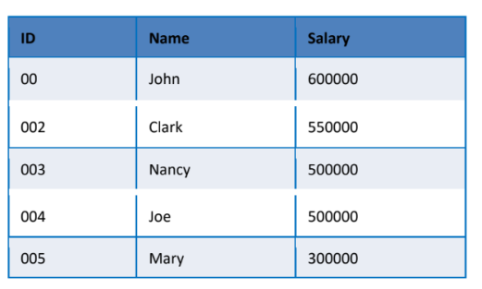

import java.util.*;

public class functionAssignment1 {

private static int[] empNums;

private static double[] empSals;

private static String[] empnames;

public int[] getEmpNums(){

return empNums;

}

public double[] getSalaries(){

return empSals;

}

public String[] getnames(){

return empnames;

}

public static void display (int[] nums, String[] names, double[] sals){

for (int i = 0; i < 5; i++)

{

System.out.println(nums[i] + " " + names[i] + " " + sals[i]);

} }

public static void main(String[]args){

Scanner sc = new Scanner(System.in);

empNums = new int[5];

empnames = new String[5];

empSals = new double[5];

for (int i = 0; i < 5; i++){

System.out.println("Please enter your employee number: ");

empNums[i] = sc.nextInt();

System.out.println("Please enter your Employee name: ");

sc.nextLine(); //so the input isn't skipped

empnames[i] = sc.nextLine();

System.out.println("Please enter your Salary: ");

empSals[i] = sc.nextDouble();

}

display(empNums, empnames, empSals);

} }

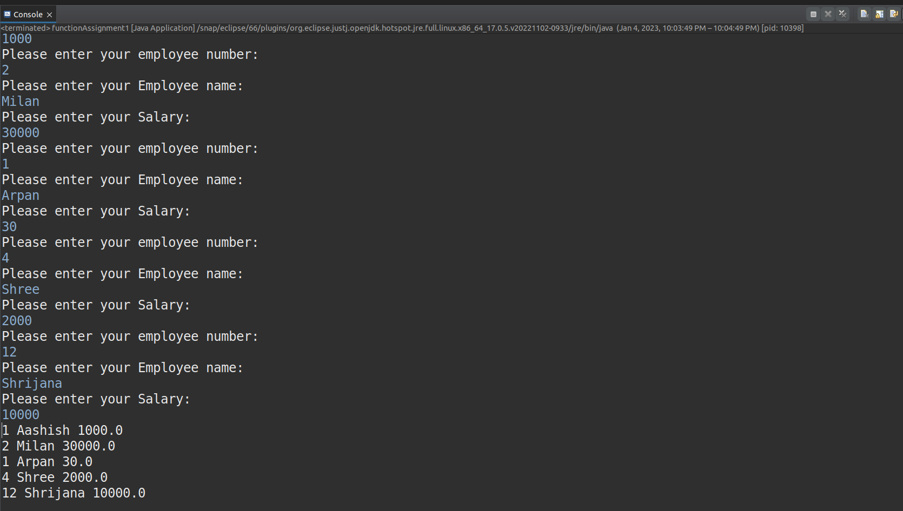

1. Write another function display () with Employee ID array and Employee name array as arguments. (Note: here we are using concept of function overloading). This function will display the content of the 2 arrays in the following format.

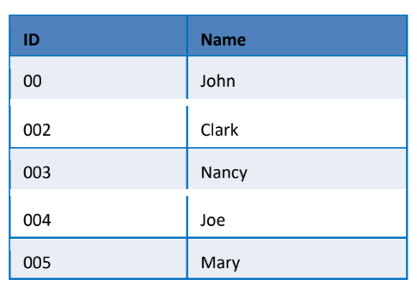

import java.io.*;

public class FunctionOverloading {

public static void main(String [] args) throws IOException{

*//This program uses function overloading for displaying the data entered by user.*

InputStreamReader in = new InputStreamReader(System.in);

BufferedReader br = new BufferedReader(in);

int [] employeeId = new int[5] ;

double [] salary = new double[5];

String [] name = new String[5];

int i;

for( i =0; i<5; i++) {

System.out.println("Enter "+(i+1)+"th employee's Id:");

employeeId[i] = Integer.parseInt(br.readLine());

System.out.println("Enter "+(i+1)+"th employee's Name:");

name[i] = br.readLine();

System.out.println("Enter "+(i+1)+"th employee's salary:");

salary[i] = Double.parseDouble(br.readLine());

}

display(employeeId,name);

}

*//Function 1 with 3 arguments id/regNo , employee name and salary*

public static void display(int [] id, String [] name, double [] salary) {

int j;

System.out.println("Id\t\t Name\t\t Salary\t\t");

for (j=0;j<5;j++) {

System.out.println(id[j]+"\t\t"+name[j]+"\t\t"+salary[j]);

} }

*//Function 2 with 2 arguments id/ regNo and employee name*

public static void display(int [] id, String [] name) {

int i;

System.out.println("\n\nId\t\t Name");

for (i=0;i<5;i++) {

System.out.println(id[i]+"\t\t"+name[i]);

} } }

**Output**



1. Write another function named display () which takes 4 arguments. The arguments are named as String and 3 arrays (Employee id, name and salary). Function prototype looks like: display (String name, int regno[], String Empname[], double salary[]).

This function will search for the name in the Empname array and will display its corresponding id and salary in the below given format. For example, if Divya is given as the name to search then display () function will display the following record.

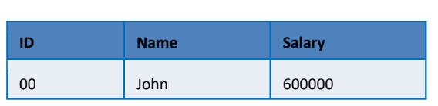

Note: main () should have the following steps:

1. Declaring the arrays.
2. Accepting data for the arrays.
3. Calling the 2 display () functions which takes 3 and 2 arguments.
4. Accept a user name to search in the array and display the record by calling the display () function which takes 4 arguments.

import java.io.*;

public class SearchData {

public static void main(String [] args) throws IOException{

*//This program uses function overloading for displaying the data entered by user and searching the user //for providing details*

InputStreamReader in = new InputStreamReader(System.in);

BufferedReader br = new BufferedReader(in);

int [] employeeId = new int[5] ;

double [] salary = new double[5];

String [] name = new String[5];

String search_name = new String();

int i;

for( i =0; i<5; i++) {

System.out.println("Enter "+(i+1)+"th employee's Id:");

employeeId[i] = Integer.parseInt(br.readLine());

System.out.println("Enter "+(i+1)+"th employee's Name:");

name[i] = br.readLine();

System.out.println("Enter "+(i+1)+"th employee's salary:");

salary[i] = Double.parseDouble(br.readLine());

}

*//Executing all functions*

display(employeeId,name,salary);

display(employeeId,name);

System.out.println("Enter name to be searched within an array :");

search_name = br.readLine();

display(search_name, employeeId, name,salary);

}

*//Function 1 with 3 arguments id/regNo , employee name and salary*

public static void display(int [] id, String [] name, double [] salary) {

int j;

System.out.println("\n\nId\t\t Name\t\t Salary\t\t");

for (j=0;j<5;j++) {

System.out.println(id[j]+"\t\t"+name[j]+"\t\t"+salary[j]);

} }

*//Function 2 with 2 arguments id regNo and employee name*

public static void display(int [] id, String [] name) {

int i;

System.out.println("\n\nId\t\t Name");

for (i=0;i<5;i++) {

System.out.println(id[i]+"\t\t"+name[i]);

} }

*//Function 3 with 4 arguments searched_name,id/regNo, employee name and salary*

public static void display(String name, int [] regNo, String [] empName, double [] salary) {

*//This functions searches the name in array, if found returns the data else returns no data found as output.*

int i,flag,j;

flag =0;

j = 5;

for(i = 0; i<5;i++) {

if(empName[i].equalsIgnoreCase(name)) {

flag = 1;

j = i;

} }

if(flag ==1) {

System.out.println("\n\nId\t\t Name\t\t Salary\t\t");

System.out.println(regNo[j]+"\t\t"+empName[j]+"\t\t"+salary[j]);

}

else if (flag == 0 && j == 5) {

System.out.println("The name of '"+name+"' is not found in array.");

} } }

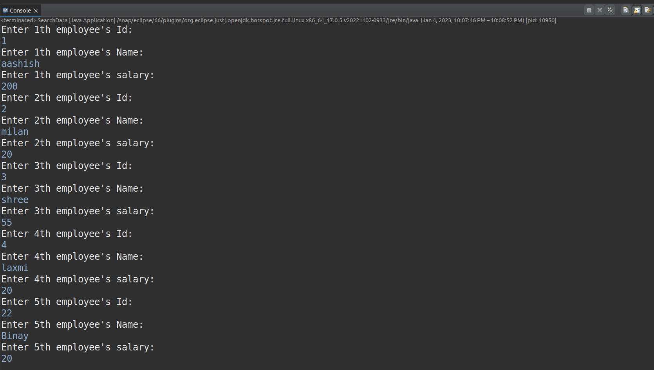

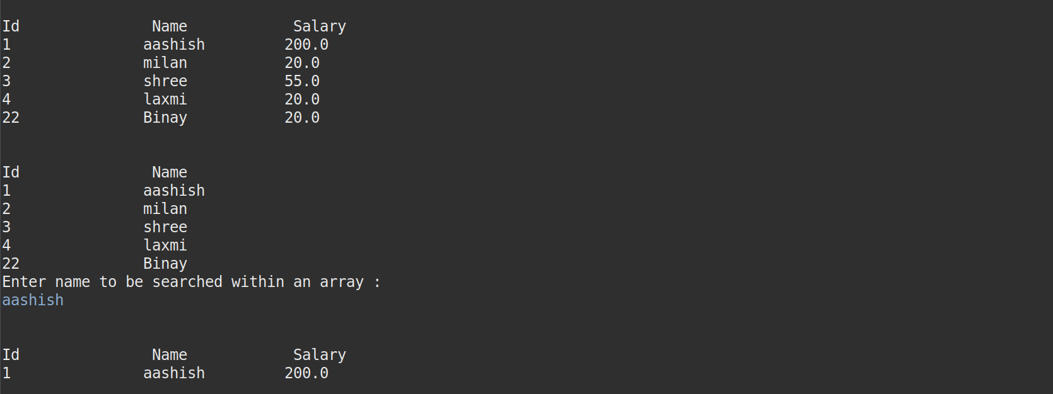

Case Study

1. Alex wants an application for his restaurant in which he needs to display the drinks available in his restaurant to the customers along with their prizes. Create an application which will display the menu items along with the prizes and once the order is done, it will calculate the total amount of the order and display it to the customers.

import java.util.Scanner;

public class Application

{

public static void main(String[] args)

{

Scanner scanner = new Scanner(System.in);

boolean loop = true;

String[] drinks = {"Lassi", "Juice", "Cider", "Fanta"};

int[] price = {30, 100, 120, 150};

int[] quantity = new int[drinks.length];

DrinksMenu[] drinksMenus = new DrinksMenu[drinks.length];

for (int i = 0; i < drinks.length; i++) {

drinksMenus[i] = new DrinksMenu(drinks[i], price[i]);

quantity[i] = 0;

}

while (loop){

System.out.println("Choose from menu for orders and press 0 to finalize");

System.out.println("SNo." + "\t\t" + "AvailableItems" + "\t" + "Price");

for (int i = 0; i < drinks.length; i++){

drinksMenus[i].displayMenu(i);

}

System.out.print("Choice: ");

int choice = scanner.nextInt();

for (int i = 0; i < drinks.length; i++){

if (choice - 1 == i)

{

System.out.println("Enter how much quantity of " + drinksMenus[i].name + " you wish to purchase: ");

quantity[i] = quantity[i] + scanner.nextInt();

}

else if (choice == 0)

{

loop = false;

} } }

double total = 0;

for (int i = 0; i < drinks.length; i++)

{

total = total + drinksMenus[i].price * quantity[i];

}

System.out.println("The total is: " + total);

} }

class DrinksMenu{

String name;

double price;

DrinksMenu()

{ }

DrinksMenu(String name, double price)

{

this.name = name;

this.price = price;

}

public void displayMenu(int i)

{

System.out.println((i + 1) + "\t\t\t" + name + "\t\t\t" + price);

} }

**Output**

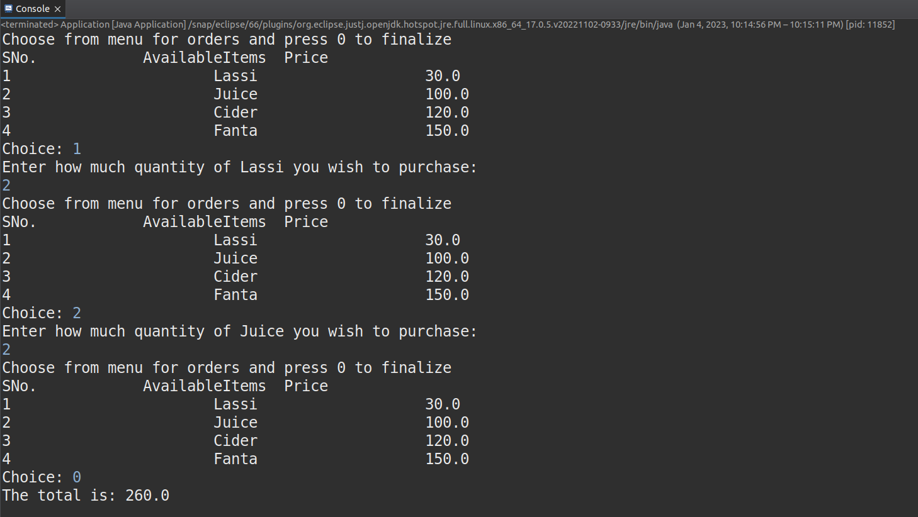

1. Consider a class named phone which have functionalities like make a call, receive a call and messaging. Based on this scenario John wants to develop an application which will have class named Mobile and methods like dial, receive and message which will demonstrate the functioning of these methods.

Use a reference object to call these methods (dial, receive and message and display).

public class Phone {public static void main(String[] args)

{

MobilePhone mp1 = new MobilePhone("Rahul", "984209865");

MobilePhone mp2 = new MobilePhone("Rohan", "985432189");

mp1.dial(mp2);

mp2.message(mp1, "I am busy, please call later");

} }

class MobilePhone

{

String name;

String number;

MobilePhone(String name, String number)

{

this.name = name;

this.number = number;

}

public void dial(MobilePhone mobile)

{

System.out.println("Dialing " + mobile.number + " " + name);

mobile.receive(mobile);

}

public void receive(MobilePhone mobile)

{

System.out.println(mobile.number + " is calling you " + name);

}

public void message(MobilePhone mobile, String msg)

{

System.out.println("\nYou have sent the message " + msg + " to " + mobile.name + ", " + mobile.number);

}

public void display()

{

System.out.println("\nName: " + name + ", Number: " + number);

} }

**Output**

